- Data page: The graphing is extremely inefficient. When I download a job, the functionality seems okay, but after it plots the data on the graph it takes a very long time to do anything with it. This is a critical problem!

i.e. with an 8000 sample data set (which is quite small), if I touch the graph to select a point, it takes 45-90 seconds to select it. Similarly, to unzoom to full level takes just as long. The app is totally unresponsive during this time. It eventually does zoom out but it takes so long it gives the impression that the app is frozen. If I start pressing other buttons during this delay (which most users undoubtedly would), it crashes the app.

Do whatever you must to improve the efficiency (i.e. if you have to not draw a dot on each sample, that’s fine). When doing things with the graph it should respond almost immediately, not a minute later.

- Data page: tapping the data grid button crashes the app. My testing suggests the grid crashes if the job’s start time is blank. I would suggest, in the case where the start time has not been set, just make the Calendar Time column blank.

- Data page – the zip file is corrupt. I use the app to download and send the data file via email, but the zip that arrives cannot be opened.

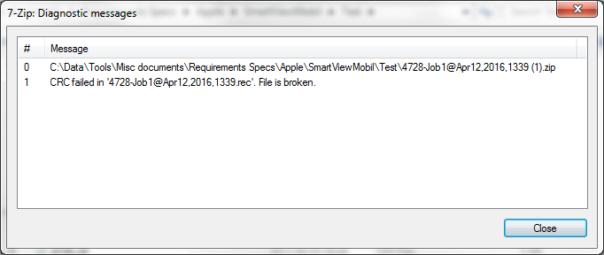
- Data page: after downloading a job or loading a file, the graph should default to full zoom. At present, after downloading data, the data is not visible on the graph at all because the graph is zoomed into the middle of nowhere.

- Data page: zoom keeps defaulting back to the nonsense level mentioned in the previous point. i.e. if I have data loaded and then unzoom to show the full data scale. Then go to Options, then back to Data, the zoom resets so data is no longer shown.

- Options page: the Atmospheric Pressure value should always be numeric. Either make the entry keyboard for this setting numeric-only or do error checking to ensure the value is a number.

- Options page: When selecting an option that pops up a scrolling selection (like pressure units or temperature units), make sure the initial highlighted item is the current setting. i.e. if pressure units are currently kpaa, then when the user selects the pressure units and you pop up the scroller, it should have kpaa selected.

The problem is, for example, if kpaa is the current setting, then when the user selects the units the scoller pops up with psia selected (not kpaa), but it doesn’t allow the user to select the psia, so in order to change it to psia, you have to change it to some other value and then change it to psia. (if you remain on the Options page, it will default to last selected value, but it should do it all the time)

- Data File (.rec): The header lines are not using Windows new lines.
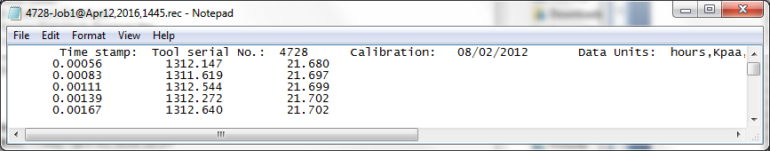

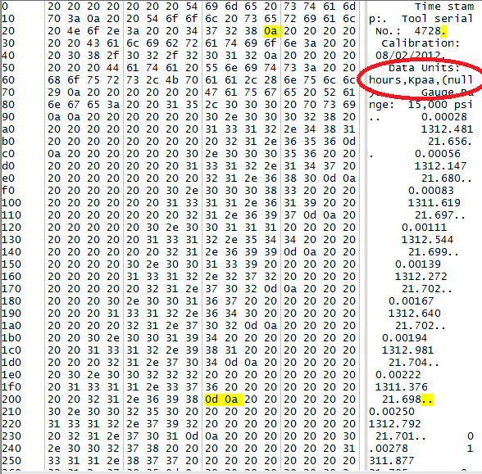

See the highlighted bytes. The data lines use Windows newlines correctly, but the header uses Apple/Unix NewLines. All newlines should be Windows newlines

- Data File: Also note that temperature units are incorrect (circled red above). Pressure units actually have the same problem. I did some testing and it looks like the bug is that the units are shown as “(null)” until the user goes in to the Options and changes them. This is no good because users will set the units only once and then never change them.

You should be able to start the device, open the app, download the job, and have the units and everything else show up properly.

- Share menu: the option “Upload” uploads the file to instaonline.net. This seems inappropriate, and I don’t think Instalogic will like it. You can leave this functionality in the code, but maybe remove the menu item. The email and txt msg options should suffice. (I can’t test SMS because my device is an iPad with no messaging)

- Share menu: there is a bug with this menu. pop up the Share menu, then tap outside the menu (not Cancel, but click beyond the menu borders). This should simply cancel the menu, but it doesn’t, it instead crashes the whole app.

